Metering Installation Error Report

(Data source: explore_1.xlsx. Error calculated: Fri Mar 13 13:54:59 2020.)
The error calculated for the given load profile is +0.26 %.
The expanded uncertainty at an estimated 95% level of confidence is 0.16 %.
The uncertainty interval extends from +0.10 % to +0.42 %.

Installation error over the phase and current ranges that match the load profile.
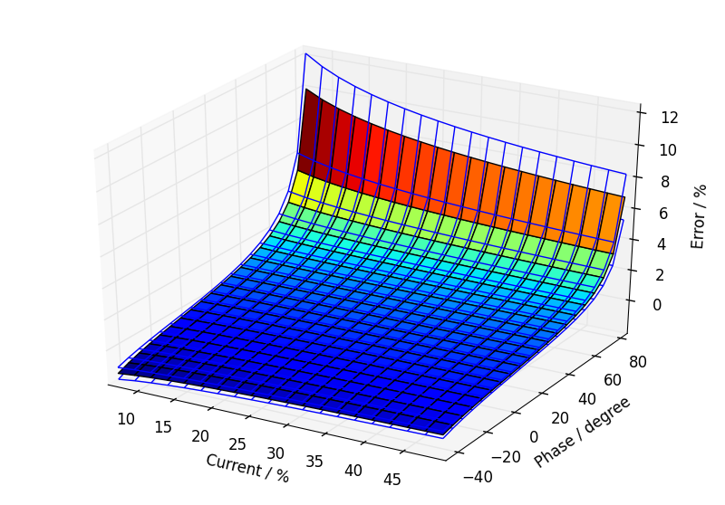

Annual load profile used for this error calculation.
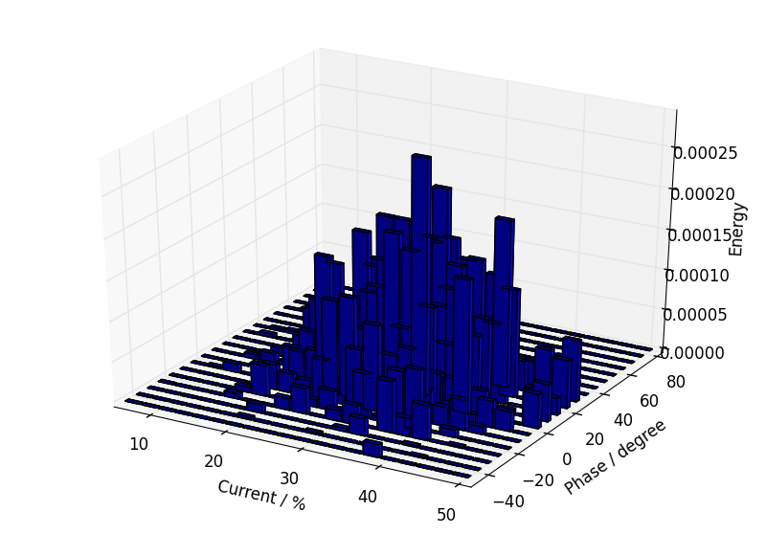

Component calibration data with calculated fits over the calibration ranges.

Current Transformer.
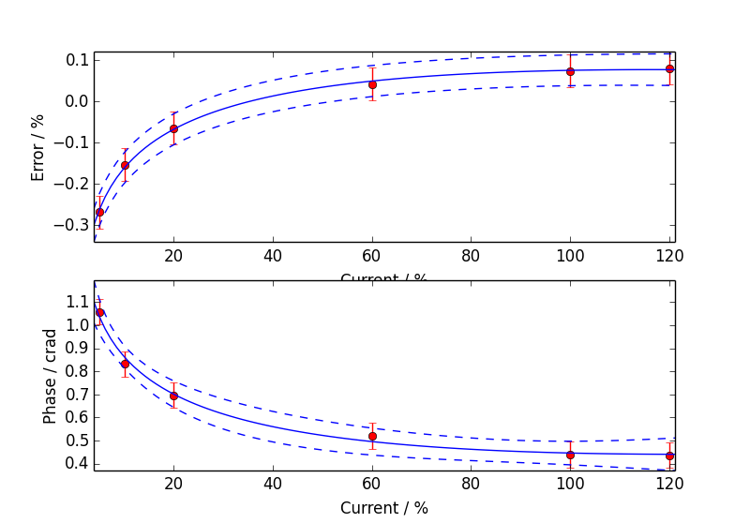

Voltage Transformer.
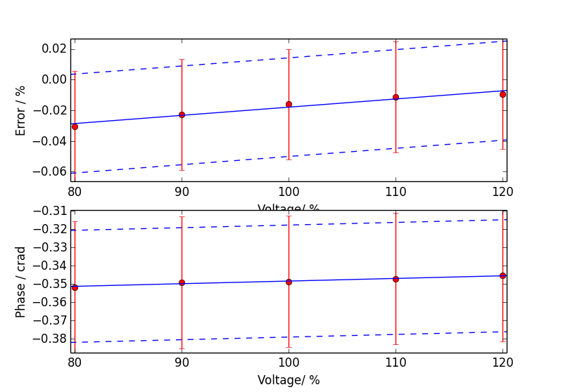

Meter.
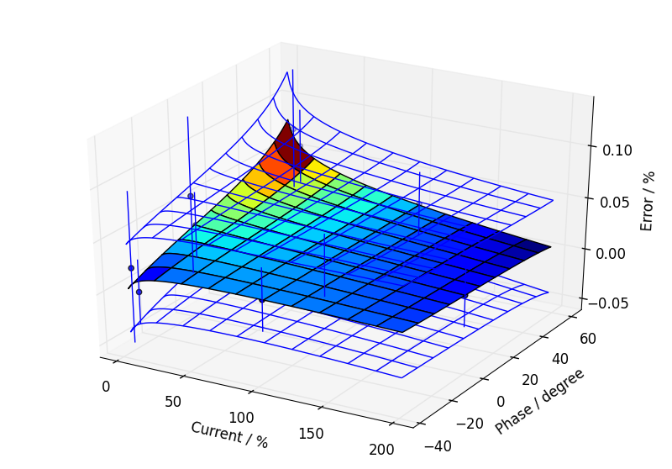

Additional Information

Uncertainty Contribution Summary
Uncertainty contribution by component as a percentage of total variance, Meter: 19 %, CT: 45 %, VT: 36 %.

Text Output From Calculation Process
Meter data
Fit has lower uncertainty than expected from calibration data, so type B component added.
CT ratio data
Fit has lower uncertainty than expected from calibration data, so type B component added.
CT phase data
Good fit.
VT ratio data
Fit has lower uncertainty than expected from calibration data, so type B component added.
VT phase data
Fit has lower uncertainty than expected from calibration data, so type B component added.

Max current = 50.59 %, Min current = 5.75 %, Max phase = 86.03 degrees, Min phase = -48.98 degrees

Budget for overall error by coefficients

0.260, u=0.079, df=120.3
a2 CT_e: 0.0663702
a0 VT_e: 0.0515479
a1 VT_e: 0.05104
a0 CT_e: 0.0418284
Meter temperature coefficient: 0.0357071
Meter harmonic dependence: 0.0282843
Site harmonics: 0.0282843
Site voltage: 0.0226716
Meter voltage dependence: 0.0212132
b0 meter: 0.0202546
a2 CT_p: 0.0185814
b0 CT_e: 0.0183737
a1 CT_e: 0.0163646
b0 VT_e: 0.0163636
CT calibration burden: 0.0155754
Site CT burden: 0.0155754
a0 VT_p: 0.0144399
a1 VT_p: 0.0142976
Meter frequency dependence: 0.0132583
Site frequency: 0.0124713
a0 CT_p: 0.0117172
a0 meter: 0.00824024
Site temperature: 0.00798931
VT calibration burden: 0.00796915
Site VT burden: 0.00796915
a1 CT_p: 0.00458842
b0 VT_p: 0.00439312
a2 meter: 0.00424807
a3 meter: 0.00416099
a1 meter: 0.00266613
CT temperature coefficient of phase: 0.000233859
VT temperature coefficient of phase: 0.000133258
CT calibration temperature: 6.07442E-05
VT calibration temperature: 3.10797E-05
VT temperature coefficient of error: 2.4479E-05
CT temperature coefficient of error: 2.12541E-05

